Task 3
Practice task
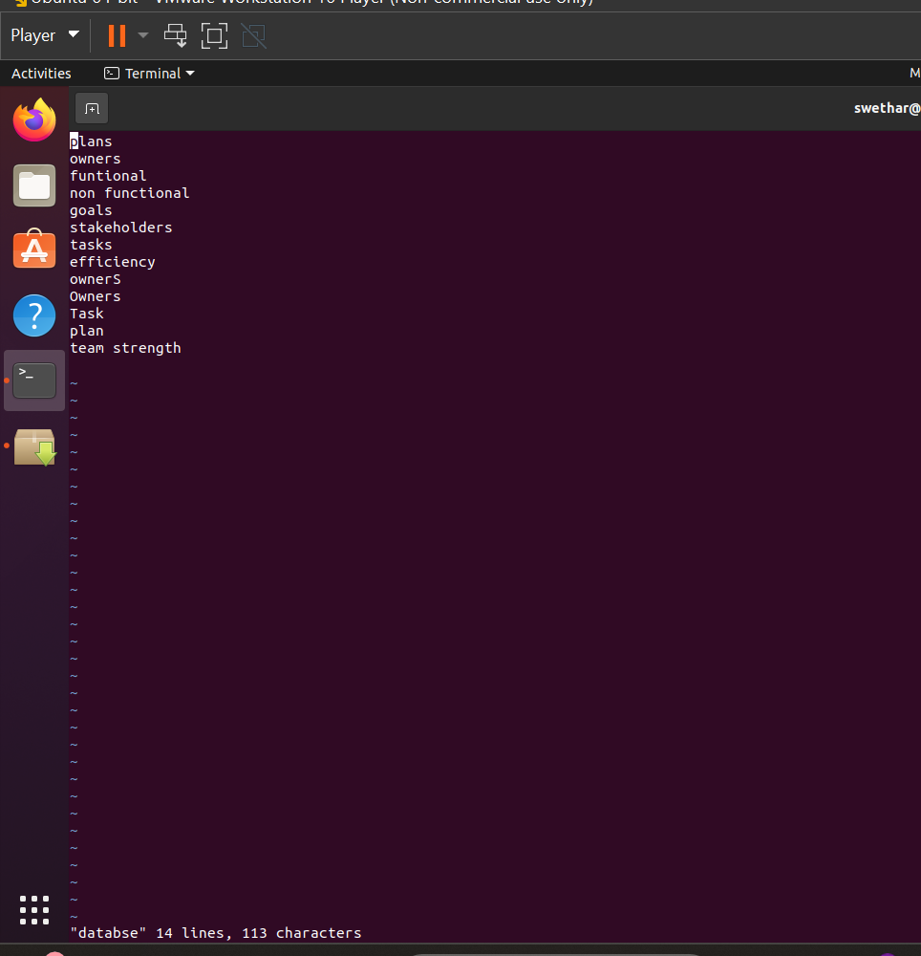
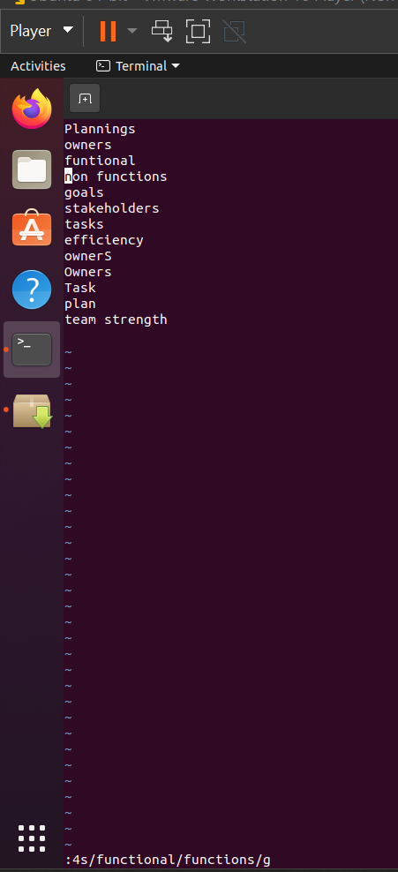

Additional task
1. How to insert a blank line, below the line where the cursor is
pointing in vi editor
2. How to search and replace case in sensitive pattern
3. How to search and replace pattern from 4th line to 10th line
4. Want is the use of man command and what is the difference between man and –help

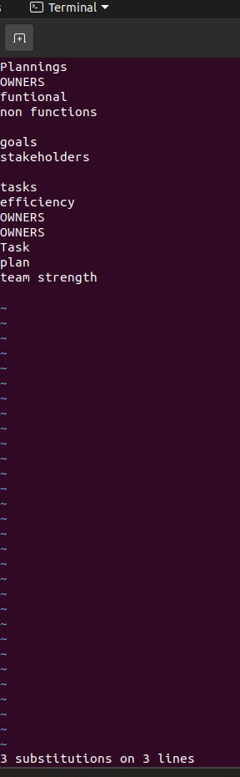
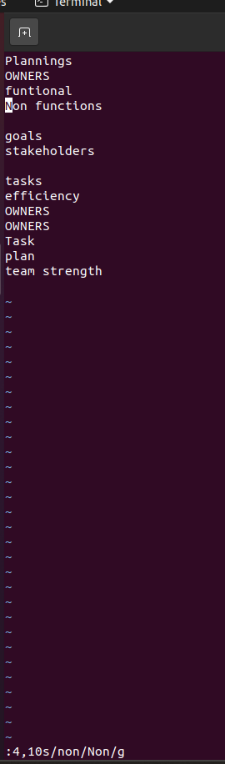

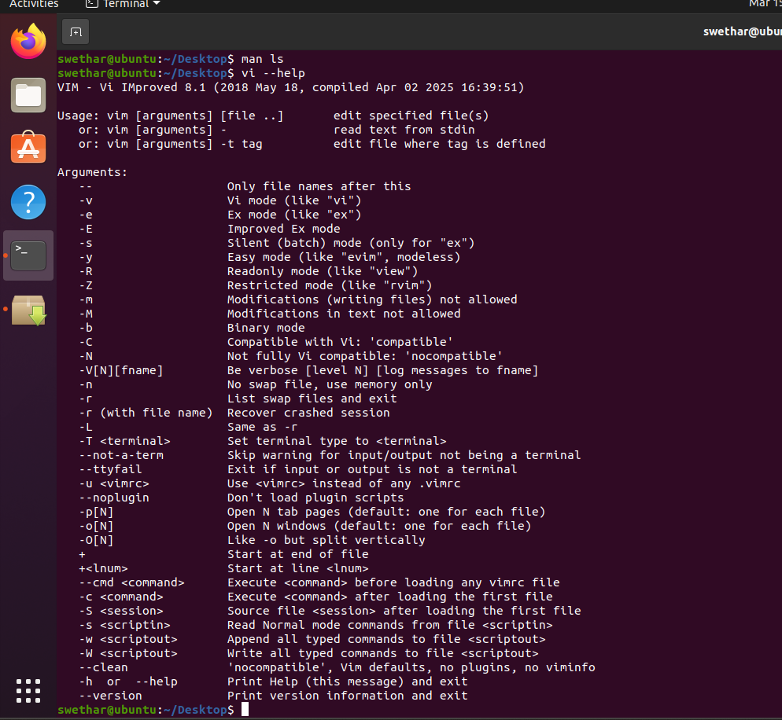

The man command (manual) is used to display the complete documentation of a command, including its description, options, examples, and detailed explanations, usually opened in a paged viewer for easy navigation. In contrast, the --help option provides a short and quick summary of the command usage and available options directly in the terminal. Therefore, man gives detailed information, while --help provides a brief overview for quick reference.

